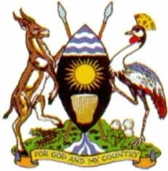
The Republic of Uganda
Alternative Communication Routes
Chief Administrative Officer………….………0782079777
DCAO………………………………………………..0783000160
Chief Finance Officer ………………………….0777253586
Email.Office:bukwodlg@gmail.com
IN ANY CORRESPONDENCE ON THIS SUBJECT,
PLEASE QUOTE: CR: /214/2

BUKWO DISTRICT LOCAL GOVERNMENT
Office of the Chief Administrative Officer
P.O BOX 2
BUKWO.

14th oct, 2022
The District chairperson,
Bukwo.

DECLARATION OF RELEASES

This is to declare to you the funds we have received for the second quarter of the f/y 2022/2023.
s/n | Details | Amount
1 | Non-wage | 855,573,307=
2 | Wage | 4,550,626,828=
3 | Development | 808,013,646=
4 | Gratuity | 132,423,003=
5 | Pension | 108,897,702=
 | TOTAL | 6,455,534,486=

This is for your information
Yours faithfully

Lorwor Jose Jimmy Walamoe.
CHIEF ADMINISTRATIVE OFFICER
Copied to: The Resident District Commissioner
The Chief Finance Officer
The Principal Internal Auditor

